JAVA FSE Mandatory Module:

MODULE1:

Exercise1: Implementing theSingleton Pattern:

Code:

Singleton.java:

public class Singleton {

    public static void main(String[] args) {

        Logger logger1 = Logger.getInstance();

        logger1.log("log message");

         Logger logger2 = Logger.getInstance();

        logger2.error(" error");

        if (logger1 == logger2) {

            System.out.println(" same instance");

        } else {

            System.out.println(" multiple instances");

        }

          logger1.warn("warning message");

    }

}

Logger.java:

public class Logger {

    private static Logger instance;

    private Logger() {

    System.out.println("Logger instance created");

    }

    public static Logger getInstance() {

        if (instance == null) {

            instance = new Logger();

        }

        return instance;

    }

    public void log(String message) {

        System.out.println("LOG: " + message);

    }

    public void error(String message) {

        System.out.println("ERROR: " + message);

    }

    public void warn(String message) {

        System.out.println("WARNING: " + message);

    }

}

Output:

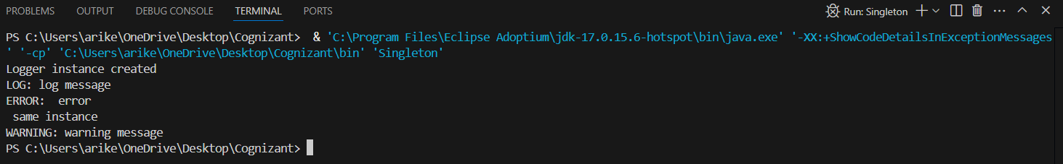

Exercise 2: Implementing the Factory Method Pattern:

Code:

Document package:

Document.java:

package documents;

public interface Document {

    void open();

    void close();

    void save();

    }

ExcelDocument.java:

package documents;

public class ExcelDocument implements Document {

    @Override

    public void open(){

        System.out.println("exelsheet");

}

    @Override

    public void close(){

        System.out.println("close excelsheet");

    }

    @Override

    public void save(){

        System.out.println("save excel");

    }

}

PdfDocument.java:

package documents;

public class PdfDocument implements Document {

@Override

public void open() {

    System.out.println("Opening PDF file");

    }

@Override

public void close() {

        System.out.println("Closing PDF file");

    }

@Override

    public void save() {

     System.out.println("Saving PDF file");

    }

}

WordDocument.java:

package documents;

public class WordDocument implements Document {

    @Override

    public void open() {

        System.out.println("Opening Word file");

    }

    @Override

    public void close() {

        System.out.println("Closing Word file");

    }

    @Override

    public void save() {

        System.out.println("Saving Word file");

    }

}

WordDocument.java:

package documents;

public class WordDocument implements Document {

    @Override

    public void open() {

        System.out.println("Opening Word file");

    }

    @Override

    public void close() {

        System.out.println("Closing Word file");

    }

    @Override

    public void save() {

        System.out.println("Saving Word file");

    }

}

factory package:

DocumentFactory.java:

package factory;

import documents.Document;

public abstract class DocumentFactory {

    public abstract Document createDocument();

   public void processDocument() {

        Document doc1 = createDocument();

        doc1.open();

        doc1.save();

        doc1.close();

    }

}

PdfFactory.java:

package factory;

import documents.Document;

import documents.PdfDocument;

public class PdfFactory extends DocumentFactory {

    @Override

    public Document createDocument() {

  return new PdfDocument();

    }

    }

ExcelFactory.java:

package factory;

import documents.Document;

import documents.ExcelDocument;

public class ExcelFactory extends DocumentFactory {

     @Override

    public Document createDocument() {

        return new ExcelDocument();

    }

    }

WordFactory.java:

package factory;

import documents.WordDocument;

import documents.Document;

public class WordFactory extends DocumentFactory{

    @Override

    public Document createDocument() {

        return new WordDocument();

    }

    }

Test.java:

import factory.\*;

public class Test{

    public static void main(String[] args) {

        DocumentFactory wordFactory = new WordFactory();

        DocumentFactory pdfFactory = new PdfFactory();

        DocumentFactory excelFactory = new ExcelFactory();

        System.out.println(" Word document:");

        wordFactory.processDocument();

        System.out.println("\nPDF document:");

        pdfFactory.processDocument();

        System.out.println("\nExcel Document:");

        excelFactory.processDocument();

    }

}

Output:

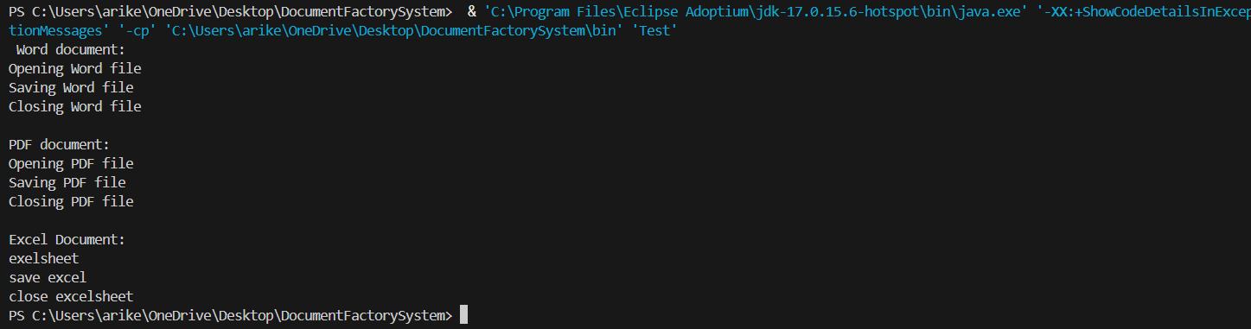

MODULE2:

Exercise 2: E-commerce Platform Search Function:

Big-0 Notation:

Two functions f(n) and g(n), we say that f(n) is O(g(n)) if there exist constants c > 0 and n0 >= 0 such that f(n) <= c\*g(n) for all n >= n0.

Performance:

Linear and Binary comparision: Best case: both has O(1), in average case O(n) for linear search and O(logn) for binary search. Coming to worst cases O(n) for linear and O(logn) for binary search.

Code:

import java.util.Arrays;

import java.util.Comparator;

public class Ecommerce {

// Product class with int id

static class Product {

int id;

String name;

String category;

public Product(int id, String name, String category) {

this.id = id;

this.name = name;

this.category = category;

}

}

//Here I cosidered string for searching

public static Product linearSearch(Product[] products, String name) {

for (Product p : products) {

if (p.name.equalsIgnoreCase(name)) {

return p;

}

}

return null;

}

// where as here I used integer array elements

public static Product binarySearch(Product[] products, int id) {

int left = 0;

int right = products.length - 1;

while (left <= right) {

int mid = left + (right - left) / 2;

int midId = products[mid].id;

if (midId == id) {

return products[mid];

} else if (midId < id) {

left = mid + 1;

} else {

right = mid - 1;

}

}

return null;

}

public static void main(String[] args) {

Product[] products = {

new Product(100, "Mouse", "Electronics"),

new Product(200, "Headphones", "Electronics"),

new Product(150, "Lamp", "Study table")

};

// Sort products by id for binary search

Arrays.sort(products, Comparator.comparingInt(p -> p.id));

// Output section

System.out.println(" Demo");

// Linear search by name

System.out.println("\n[Linear Search Using Name]");

String searchName = "Mouse";

Product foundByName = linearSearch(products, searchName);

if (foundByName != null) {

System.out.printf("Found: %s ,ID: %d\n",

foundByName.name, foundByName.id);

} else {

System.out.println("Product not found.");

}

// Binary search by ID

System.out.println("\n[Binary Search by ID]");

int searchId = 20;

Product foundById = binarySearch(products, searchId);

if (foundById != null) {

System.out.printf("Found: %s ,Category: %s\n",

foundById.name, foundById.category);

} else {

System.out.println("Product not found.");

}

}

}

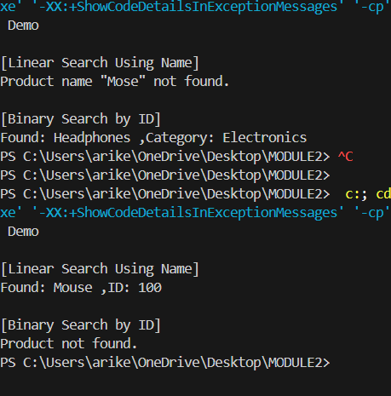

Performance Analysis:

Binary Search is more optimal compared to linear search as it has time complexity of O(log n).

Exercise 7: Financial Forecasting:

Code:

public class Interest {

    // This method calculates the future value using compound interest

    public static double Intrest(

        double P,

        double annualRate

        int years,

        int N

    ) {

        // Formula: A = P \* (1 + r/n) ^ (n \* t)

        return P \* Math.pow(

            1 + (annualRate / 100) / N,

            N \* years

        );

    }

    public static void main(String[] args) {

        double P = 1000.0

        double annualRate = 6;

        int years = 5;

        int N = 365;

        double futureValue = Intrest(P, annualRate, years, N);

        System.out.printf(

            "$%.2f invested at %.1f%% annual rate for %d years  grows to $%.2f",

            P, annualRate, years, futureValue

        );

    }

}

Output:

